Mountain Laurel Information Template
Use the styles listed below in the document. You can remove instruction text and examples in your file.

Heading Styles in Document

Heading 1 = <Title>

Heading 2 =< main topic>

Heading 3 = Subtopic

Other Styles
Instruction text for a blue box.
Bibliography for hanging indents. Use manual page break before
Any URLs to create hanging indent.
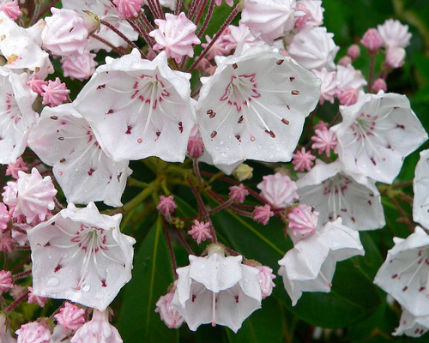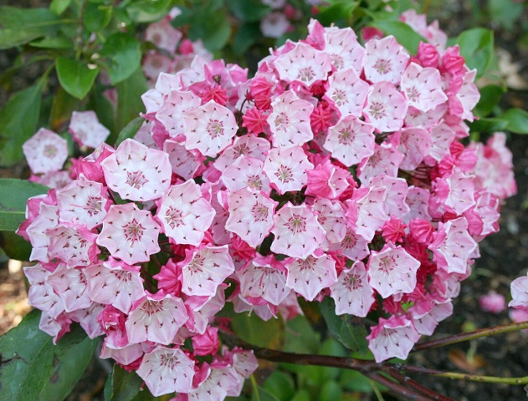
<Caption style here> Mountain laurel blooms. Pictures by Wikipedia User Arx Fortis and A. Barra respectively.

Sample References
<For hanging indents use Bibliography Style>
European Kalima Society (n.d.) Parks & Gardens
https://www.kalmia-society.org/en/?job=diary#parks
Retrieved June 29, 2023
PA Department of Conservation and Natural Resources (DCNR). (n.d.) "Mountain Laurel: Pennsylvania's State Flower"
http://elibrary.dcnr.pa.gov/PDFProvider.ashx?action=PDFStream&docID=1738488&chksum=&revision=0&docName=teFlower&nativeExt=pdf&PromptToSave=False&Size=181799&ViewerMode=2&overlay=0
Retrieved June 29, 2023
Royal Horticultural Society (n.d.) "Kalmia latifolia"
https://www.rhs.org.uk/plants/9708/kalmia-latifolia/details
Retrieved June 29, 2023
Sitch, Kelly (2021) "How the mountain laurel became Pennsylvania’s state flower."
https://pawilds.com/how-the-laurel-became-pennsylvanias-state-flower/
Retrieved June 29, 2023
Wikipedia (n.d.) "Kalima latifolia"
https://en.wikipedia.org/wiki/Kalmia_latifolia
Retrieved June 29, 2023

