Location and Jurisdiction of U.S. “Circuit” Courts and
Pennsylvania Districts

About the Circuits in the U.S. Court of Appeals
There are 13 appellate courts that sit below the U.S. Supreme Court, and they are called the U.S. Courts of Appeals. The 94 federal judicial districts are organized into 12 regional circuits, each of which has a court of appeals. The appellate court’s task is to determine whether or not the law was applied correctly in the trial court. Appeals courts consist of three judges and do not use a jury.
–U.S. Courts.gov
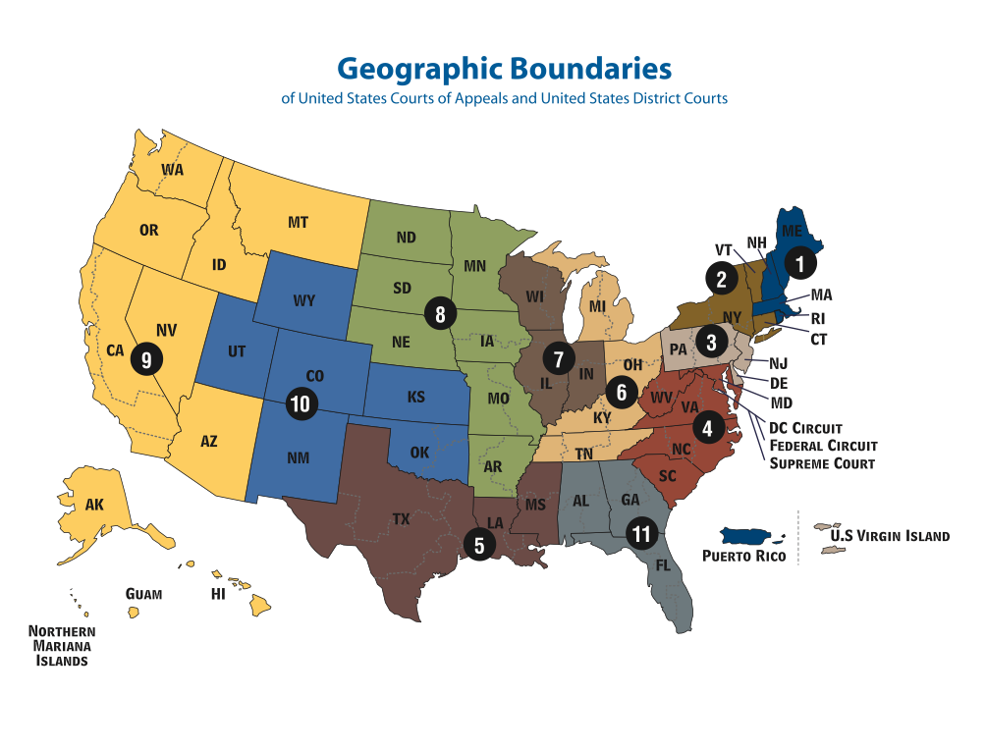
See the list of circuits and districts on the next page.

List of Circuits
The circuits and the subsidiary jurisdictions are listed below:

Circuit Table
Note: Numbers in parentheses are used for states with multiple districts.
Circuit | Primary Duty Station | States/Territories
1st | Boston | Massachusetts, Maine, New Hampshire, Rhode Island, Puerto Rico
2nd | New York | New York (4), Connecticut, Vermont
3rd | Philadelphia | Pennsylvania (3), New Jersey, Delaware, U.S. Virgin Islands
4th | Richmond | Virginia (2), Maryland, West Virginia (2), North Carolina (3), South Carolina
5th | New Orleans | Louisiana (3), Texas (4), Mississippi (2)
6th | Cincinnati | Ohio (2), Michigan (2), Kentucky (2), Tennessee (3)
7th | Chicago | Illinois (3), Indiana (2), Wisconsin (2)
8th | St. Louis | Missouri (2), Arkansas (2), Nebraska, Iowa (2), Minnesota, North Dakota, South Dakota
9th | San Francisco | California (4), Oregon, Washington (3), Alaska, Hawaii, Nevada, Arizona, Idaho, Montana, Guam, Northern Mariana Islands
10th | Denver | Colorado, Wyoming, Utah, New Mexico, Oklahoma (3), Kansas
11th | Atlanta | Georgia (3), Alabama (3), Florida (3)
DC | Washington DC | District of Columbia

Circuits and Districts

First Circuit (Boston)
- District of Maine
- District of Massachusetts
- District of New Hampshire
- District of Puerto Rico
- District of Rhode Island

Second Circuit (New York City)
- District of Connecticut
- Eastern District of New York
- Northern District of New York
- Southern District of New York
- Western District of New York
- District of Vermont

*Third Circuit (Philadelphia)
- District of Delaware
- District of New Jersey
- **Eastern District of Pennsylvania
- **Middle District of Pennsylvania
- **Western District of Pennsylvania
- District of the Virgin Islands

Fourth Circuit (Richmond)
- District of Maryland
- Eastern District of North Carolina
- Middle District of North Carolina
- Western District of North Carolina
- District of South Carolina
- Eastern District of Virginia
- Western District of Virginia
- Northern District of West Virginia
- Southern District of West Virginia

Fifth Circuit (New Orleans)
- Eastern District of Louisiana
- Middle District of Louisiana
- Western District of Louisiana
- Northern District of Mississippi
- Southern District of Mississippi
- Eastern District of Texas
- Northern District of Texas
- Southern District of Texas
- Western District of Texas

Sixth Circuit (Cincinnati)
- Eastern District of Kentucky
- Western District of Kentucky
- Eastern District of Michigan
- Western District of Michigan
- Northern District of Ohio
- Southern District of Ohio
- Eastern District of Tennessee
- Middle District of Tennessee
- Western District of Tennessee

Seventh Circuit (Chicago)
- Central District of Illinois
- Northern District of Illinois
- Southern District of Illinois
- Northern District of Indiana
- Southern District of Indiana
- Eastern District of Wisconsin
- Western District of Wisconsin

Eighth Circuit (St. Louis)
- Eastern District of Arkansas
- Western District of Arkansas
- Northern District of Iowa
- Southern District of Iowa
- District of Minnesota
- Eastern District of Missouri
- Western District of Missouri
- District of Nebraska
- District of North Dakota
- District of South Dakota

Ninth Circuit (San Francisco)
- District of Alaska
- District of Arizona
- Central District of California
- Eastern District of California
- Northern District of California
- Southern District of California
- District of Guam
- District of Hawaii
- District of Idaho
- District of Montana
- District of Nevada
- District of the Northern Mariana Islands
- District of Oregon
- Eastern District of Washington
- Western District of Washington

Tenth Circuit (Denver)
- District of Colorado
- District of Kansas
- District of New Mexico
- Eastern District of Oklahoma
- Northern District of Oklahoma
- Western District of Oklahoma
- District of Utah
- District of Wyoming

Eleventh Circuit (Atlanta)
- Middle District of Alabama
- Northern District of Alabama
- Southern District of Alabama
- Middle District of Florida
- Northern District of Florida
- Southern District of Florida
- Middle District of Georgia
- Northern District of Georgia
- Southern District of Georgia

District of Columbia Circuit (Washington)
- District of Columbia

Federal Circuit (Washington)

Courts
- Court of Appeals for Veterans Claims
- Court of Federal Claims
- Court of International Trade

Administrative agencies
- Armed Services Board of Contract Appeals
- Bureau of Justice Assistance
- Civilian Board of Contract Appeals
- International Trade Commission
- Merit Systems Protection Board
- Office of Congressional Workplace Rights[E]
- Patent Trial and Appeal Board
- Personnel Appeals Board
- Trademark Trial and Appeal Board

Pennsylvania District Courts

Eastern District of Pennsylvania

E.D. Courts
- Allentown
- Philadelphia
- Reading

E.D. Counties
Berks, Bucks, Chester, Delaware, Lancaster, Lehigh, Montgomery and Northampton

Middle District of Pennsylvania

M.D. Courts
- Harrisburg
- Scranton
- Wilkes-Barre
- Williamsport

M.D. Counties
Adams, Bradford, Cameron, Carbon, Centre, Clinton, Columbia, Cumberland, Dauphin, Franklin, Fulton, Huntingdon, Juniata, Lackawanna, Lebanon, Luzerne, Lycoming, Mifflin, Monroe, Montour, Northumberland, Perry, Pike, Potter, Schuylkill, Snyder, Susquehanna, Sullivan, Tioga, Union, Wayne, Wyoming, and York.

Western District of Pennsylvania

W.D. Courts
- Erie
- Johnstown
- Pittsburgh

W.D. Counties
Allegheny, Armstrong, Beaver, Bedford, Blair, Butler, Cambria, Clarion, Clearfield, Crawford, Elk, Erie, Fayette, Forest, Greene, Indiana, Jefferson, Lawrence, McKean Mercer, Somerset, Venango, Warren, Washington, Westmoreland

