Information Technology Services
Penn State Accessibility Quickstart Guide • http://accessibility.psu.edu

Creating Accessible Blogs

Introduction
The Blogs at Penn State system includes some accessibility features, but instructors can take the following precautions to ensure full accessibility.

Images
Text-only blogs are generally accessible to everyone, but those with images can cause problems unless special precautions are taken.
Just as with conventional websites, images in blogs need to be equipped with alt text in order to be comprehensible to screen reader users.
To insert an image with alt text:
- When creating or editing a blog entry, click the Insert Image button in the formatting toolbar.
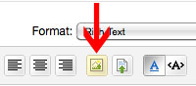
- After uploading the image, enter a short description in the Name field; this will become the image’s alt text.
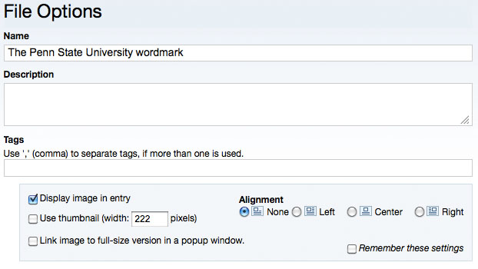
- Configure any additional attributes of the image such as alignment and thumbnail size.
- Click Finish.
Note: Because you cannot edit a file’s options, you must upload a new image to equip it with a “Name,” and therefore with alt text.

Student Blog Entries
If your course requires posting entries to a blog, some students with disabilities may encounter problems creating and writing blog entries. If a student reports a problem, consider alternate outlets such as the student forwarding an e-mail message/Word file, or allowing a tech-savvy student to use another Web technology.
Accessibility problems that a student encounters writing blog entries can be reported to blogs@psu.edu.

Other Uploaded Files
Other files that are uploaded to the Blogs such as PDFs, podcasts or PowerPoint files should be made as accessible as possible, especially if they are used in a course. See Penn State’s Accessibility and Usability Guide (http://accessibility.psu.edu) for more information on making these files accessible.

Using HTML Mode and CSS
See following page for information

Using HTML Mode and CSS

Additional Information
For more information on accessibility, see http://accessibility.psu.edu.
For more information on using Blogs, see http://kb.its.psu.edu/blogs.

Although the output of The Blogs at Penn State is generally accessible, there are always improvements that can be made. If you are comfortable using HTML Mode and/or CSS, consider these options.
- In the default WYSIWYG Mode, paragraph breaks are coded as <br />, but in HTML Mode breaks can be replaced with <p> tags enclosing the paragraph. Using “<p>” tags allows screen reader users to jump between paragraphs.
To enable HTML Mode, click the HTML Mode icon in the formatting toolbar.
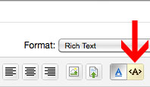
- Section headers within a blog entry can be tagged with <H3> tags. This allows screen reader users to easily jump through the sections of a page. The easiest way to make this change is in HTML Mode.

You may want to modify the default style sheet to make H3 more distinct. See http://www.personal.psu.edu/ejp10/blogs/tlt/2011/10/styling-blogs-for-accessibilit.html for more information.
See support documentation at The Blogs at Penn State (http://blogs.psu.edu) for information on how to access style sheets and templates.

